**Cocoa Tea**

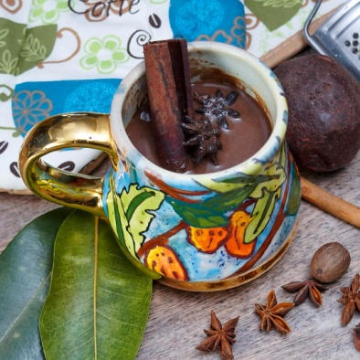

For many of us, “Cocoa Tea” is something we saw our grandmothers make but never attempted ourselves. Chrisal reminisces on having this every Christmas with her family and is in the kitchen today to show you just how easy it is to make. She also includes her variation to this classic hot beverage that makes it the perfect thing to drink on a cold rainy day.

We call it “Cocoa Tea” but it’s not to be confused with the packaged “hot chocolate with marshmallows” you get in the grocery store. This has a DEEP and rich chocolatey flavor together with a blend of spices that warms you up inside.

**INGREDIENTS**

3/4 cup of grated raw cocoa

1 1/2 cups of water

1 1/2 cups of coconut evaporated milk or regular evaporated milk

1/2 cup of coconut milk if using evaporated milk (optional)

2 bay leaves

1 cinnamon stick

1 1/2 tsp of cinnamon powder

1/2 tsp of freshly grated nutmeg

3 or 4 star anise

1 tbsp of mace

1 pinch of salt

Condensed milk or sugar sweetened to your liking

**METHOD**

1. Add water to the pot along with cinnamon, nutmeg, bay leaf, nutmeg, mace and star anise and bring to boil
2. Once the water has boiled and is fragrant lower the heat and add chocolate, stirring in to ensure it’s incorporated.
3. Simmer for about 10 minutes and stir occasionally then add milk, salt and sweeten to your taste.
4. Oil deposits may be evident at the top but that’s from the cocoa itself and is perfectly normal.
5. Strain and serve hot with cinnamon stick and additional grated nutmeg.